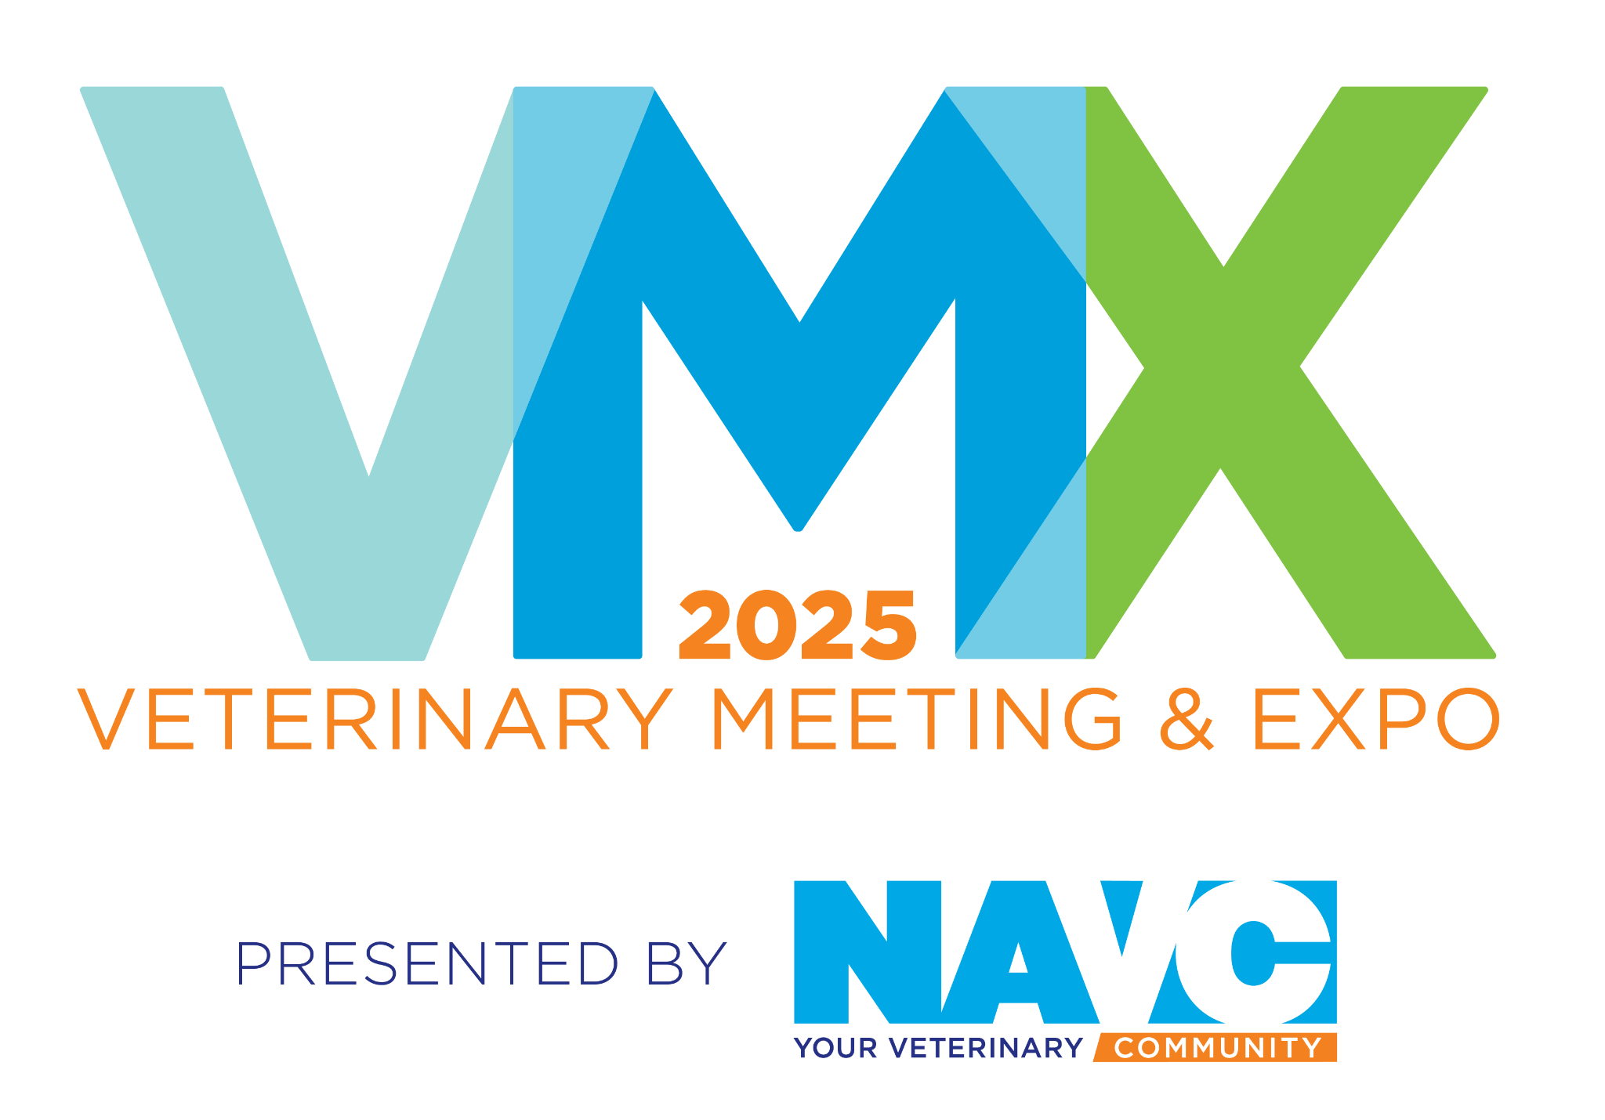

**FOR IMMEDIATE RELEASE**

**MEDIA CONTACTS**: Robin Pence | rpence@navc.com | M: +1.352.317.8651  
 Alexia Rose | Alexia@inspireprgroup.com | M: +1.740.973.9809

**Ease Pet Vet Takes Top Prize at 8th Annual Pet Pitch Competition at VMX 2025**

*Startup company provides greater access to board-certified veterinary behaviorists*

**ORLANDO, FL – FEB. 06, 2025 –** Innovation and creativity took center stage at the 8th Annual Pet Pitch Competition, a highly anticipated annual event showcasing cutting-edge startups poised to transform veterinary medicine. Held during the [2025 Veterinary Meeting & Expo (VMX)](https://navc.com/vmx) hosted by the North American Veterinary Community (NAVC), this Shark Tank-style business pitch event provides a platform for emerging companies to present solutions for some of the veterinary industry’s most pressing challenges.

This year, [**Ease Pet Vet**](https://easepetvet.com/) claimed the top prize for its groundbreaking behavioral health platform, which is designed to bridge the gap between general practice veterinarians and board-certified veterinary behaviorists. Common behavioral problems like separation anxiety and reactivity are among the top reasons pets are surrendered to shelters; this forward-thinking solution offers science-based, tailored treatment to help pets and families thrive.

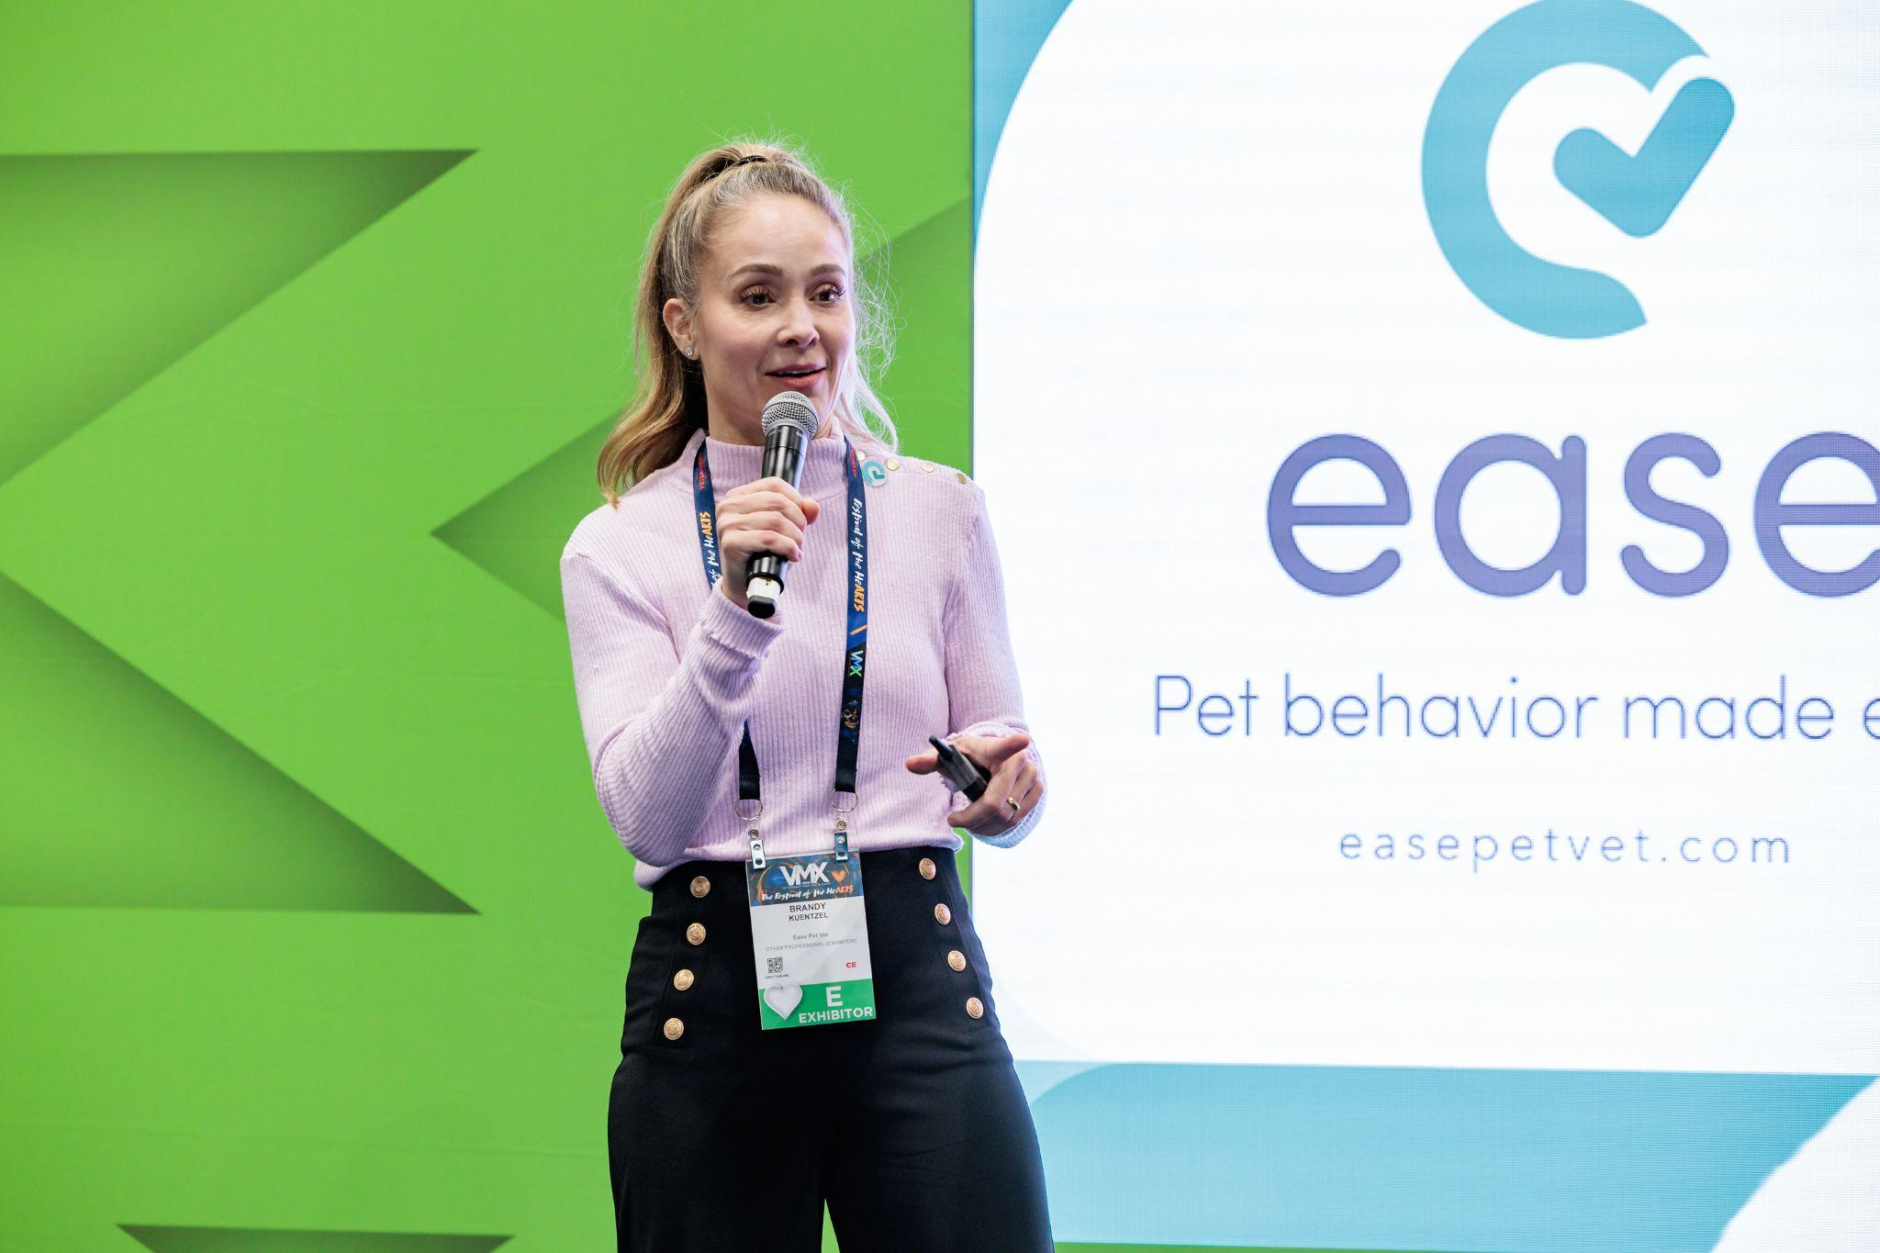

Ease Pet CEO, Brandy Kuentzel presenting at the Pet Pitch Competition at VMX 2025, presented by the North American Veterinary Community

"Access to veterinary behavior care remains tragically limited. While an estimated 15 million pets need this crucial support, the current system serves a mere 50,000 annually,” said Ease Pet Vet CEO Brandy Kuentzel. “With many states lacking even a single board-certified veterinary behaviorist, the gaps in care are staggering. Yet, research shows that 94% of pets who receive veterinary-guided behavior support avoid surrender, highlighting how we keep pets in their loving homes. The founding veterinary team at Ease Pet Vet has already demonstrated the potential for change, having helped more than 100,000 pets lead happier, healthier lives. Winning the VMX Pet Pitch Competition supercharges what we do at Ease, unlocking greater access to veterinary behavior care and ultimately helping more pets."

“Ease Pet Vet’s behavioral health platform is an excellent example of how technology and forward-thinking innovation can bridge gaps in pet care, making essential behavioral treatment more accessible to veterinarians and—most importantly—pets in need,” said Gene O’Neill, CEO of the NAVC, which presents the annual VMX event. “The VMX annual Pet Pitch Competition continues to showcase and accelerate groundbreaking innovations like this, providing a platform for startups that are shaping the future of veterinary medicine.”

In addition to Ease Pet Vet’s first-place win, [**Kubanda Cryotherapy**](https://kubandacryotherapy.com/) earned second place for its minimally invasive cancer treatment that improves the quality of life for pets by offering a cost-effective alternative to traditional surgeries. [**CoVet**](https://www.co.vet/), an AI-powered scribe and copilot app designed to automate administrative tasks for veterinarians, took third place. **Kubanda Cryotherapy** also received the audience favorite award, created in honor of Kelly Clay, a lifelong advocate for startups. Winners receive cash awards to enable their growth.

The annual Pet Pitch Competition has become a staple at [VMX](https://www.prnewswire.com/news-releases/shaping-the-future-of-veterinary-medicine-vmx-2025-to-advance-health-care-for-beloved-pets-wildlife-and-species-across-the-animal-kingdom--from-dogs-and-cats-to-kangaroos-and-honey-bees-302322620.html), offering startups a valuable platform to share their innovations with a global audience. As the veterinary industry’s first major event of the year, VMX sets the stage for innovation and progress, showcasing cutting-edge advancements that transform the lives of animals and the professionals who care for them.

Learn more about VMX 2025 and the Pet Pitch Competition from NAVC [here](https://navc.com/vmx-event/startup-circle-pet-pitch/).

**About the NAVC**The North American Veterinary Community (NAVC) is a 501(c)(3) nonprofit organization dedicated to supporting and advancing veterinary professionals worldwide. As the world’s leading provider of veterinary continuing education, the NAVC delivers essential training, tools and resources for veterinary professionals to stay abreast of advances in animal medicine and provide the best care for animals everywhere. Through its commitment to innovation and excellence, the NAVC has developed a diverse portfolio of products and services, including: educational events, headlined by VMX (Veterinary Meeting & Expo), the world’s largest, most comprehensive continuing education conference and launchpad for new products and innovations within the veterinary industry; VetFolio.com, a robust digital platform for virtual learning and engagement; NAVC Media, the veterinary industry’s largest and award-winning portfolio of trade publications; and Embrace, an advocacy arm which unites the veterinary community and pet lovers. The NAVC was founded in 1982 and is headquartered in Orlando, FL. Since 2017, the NAVC has been recognized annually as one of the Top Workplaces by the Orlando Sentinel. To learn more about the NAVC’s products and brands, visit<https://navc.com/>. To see our schedule of upcoming events, visit<https://navc.com/calendar/>.

###

[HIGH-RESOLUTION PHOTOS ARE AVAILABLE TO ACCOMPANY THIS RELEASE HERE.](https://usw2.nyl.as/t1/41/3z7ozoin5ssn4ph9udm6v57hx/0/c8b1a13314cf947f2c42c0f7bd789f32d5b52dc469d002bced71e76934f33c09) Photo credit: North American Veterinary Community.